**Title : College Management**

**1. Project Overview**

This project focuses on developing a College Management System, designed to streamline the management of teachers, faculties, students, scorecards, and sports activities. The system addresses the challenge of reducing manual effort, centralizing data, and improving communication across various departments.

The goal is to deliver a comprehensive digital solution by leveraging web technologies, cloud platforms, and automation tools. Through this project, we aim to:

- Improve operational efficiency by automating processes such as attendance tracking, exam scheduling, and fee payments.

- Enhance user experience by providing separate portals for students, teachers, and faculties to access information, submit reports, and communicate.

- Ensure data accuracy by maintaining records of students' academic performance, scorecards, and participation in sports activities.

- Promote sports and extracurricular engagement by tracking participation and achievements in college events.

This project will support the long-term goals of the institution by fostering better collaboration, improving academic and extracurricular tracking, and enabling effective decision-making for both administrators and faculty.

**2. Objectives**

The **College Management System** aims to achieve the following specific, measurable goals:

**Business Goals:**

* **Automate administrative processes** to reduce manual workload and errors.
* **Improve communication** between students, teachers, and faculty through centralized portals.
* **Enhance academic and extracurricular performance tracking** for students.
* **Optimize data management** for academic records, fee payments, and attendance.
* **Promote sports activities** by maintaining real-time participation and achievement records.

**Specific Outcomes:**

* **User portals** for students, teachers, and faculties with role-based access.
* **Attendance tracking and reporting** system integrated with student scorecards.
* **Scorecard management system** for recording academic performance and generating reports.
* **Sports management module** to track participation and achievements.
* **Automated notifications and reminders** for events, deadlines, and fee payments.
* **Dashboard and analytics features** for administrators to monitor institutional performance and student progress.

**3. Salesforce Key Features and Concepts Utilized**

The project leverages Salesforce functionalities to manage data effectively and enhance system performance:

* **Objects and Relationships:**
  + **Custom Objects** for students, teachers, faculties, scorecards, and sports records.
  + **Object Relationships (Lookup/Master-Detail)** to link students with scorecards, teachers with faculties, and sports participation records.
* **Automated Flows and Workflows:**
  + **Autolaunched flows** to automate attendance recording and fee reminders.
  + **Approval processes** for managing faculty leaves and student requests.
* **Reports and Dashboards:**
  + Real-time **dashboards** to monitor academic progress, fee collection, and sports activities.
  + **Custom reports** for scorecard analysis and attendance tracking.
* **Chatter and Notifications:**
  + **Chatter posts** for student-teacher communication and announcements.
  + **Email alerts** for important events, deadlines, and payment reminders.
* **Security and Access Control:**
  + **Profiles and Permission Sets** to ensure secure, role-based access for students, teachers, and administrators.
* **Mobile Access:**
  + Salesforce **mobile app integration** to allow students and teachers to access information on the go.

This project showcases how Salesforce’s robust platform enables seamless management of academic and administrative data, fostering better coordination and performance.

**4. Detailed Steps to Solution Design**

The design of the **College Management System** includes well-structured data models, user-friendly interfaces, and clear business logic to meet the project’s objectives.

**Data Models**

* **Custom Objects:**
  + **Student__c:** Stores student details (name, email, attendance, academic year).
  + **Teacher__c:** Stores teacher details (name, department, email, subject taught).
  + **Faculty__c:** Represents faculty members and their assigned departments.
  + **Scorecard__c:** Tracks academic performance for each student (subjects, grades).
  + **Sports_Record__c:** Stores student participation and achievements in sports events.
* **Relationships:**
  + **Lookup relationship** between Student__c and Scorecard__c (one-to-many).
  + **Master-detail relationship** between Faculty__c and Teacher__c.
  + **Lookup between Student__c and Sports_Record__c`** to track extracurriculars.

**User Interface Designs**

1. **Student Portal:**
   * View personal information, attendance, scorecards, and sports records.
   * **Screenshot:**

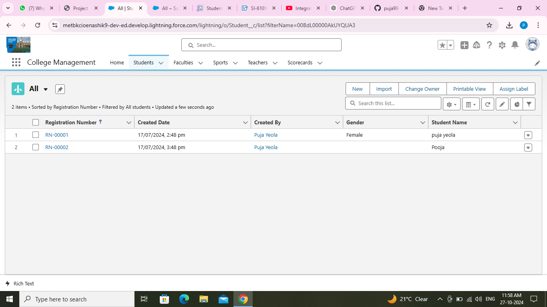

1. **Teacher Portal:**
   * Manage attendance, submit grades, and view scorecards..
   * **Screenshot:**

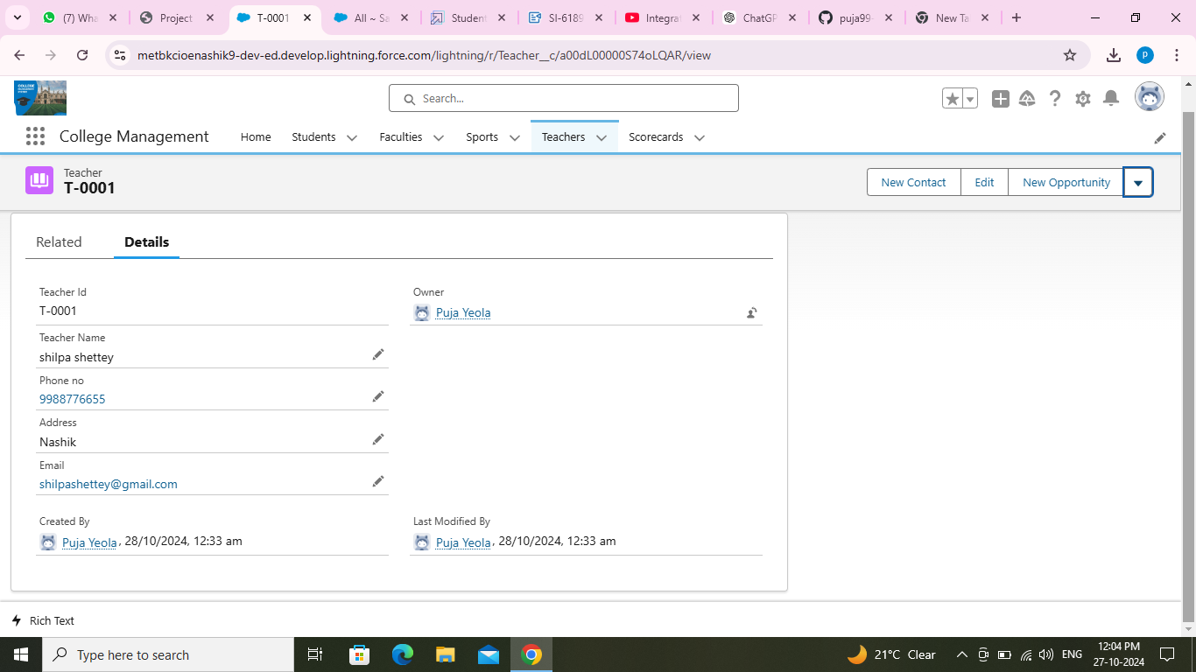

1. **Administrator Dashboard:**
   * Monitor fee payments, generate performance reports, and manage faculty.
   * View sports participation statistics and academic trends.
   * **Screenshot:**

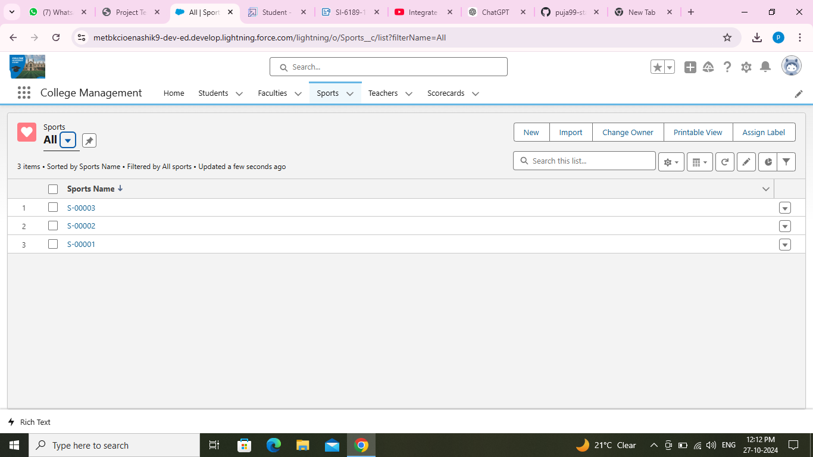

**Business Logic**

* **Flows:**
  + **Autolaunched Flow:** Automatically updates attendance and generates alerts if attendance falls below a threshold.
  + **Process Builder:** Triggers fee reminders 10 days before the due date.
* **Apex Classes:**
  + **ScorecardUpdateHelper:** Updates a student’s average grade when a new score is added.
  + **SportsAchievementTrigger:** Automatically updates a student's profile with achievements when a sports event is completed.

**5. Testing and Validation**

**Unit Testing (Apex Classes, Triggers)**

* **Apex Class Tests:**
  + Create **test data** for students, teachers, and scorecards.
  + Write unit tests for the ScorecardUpdateHelper to ensure scores are correctly aggregated.
  + **Test Coverage:** Aim for **100% code coverage** for all custom classes and triggers.
* **Trigger Testing:**
  + Validate that the SportsAchievementTrigger correctly updates student records.
  + Test scenarios where records are created, updated, and deleted to ensure triggers behave as expected.
* **Example Apex Test Code:**
* java code:

@isTest  
private class ScorecardUpdateTest {  
    static testMethod void testUpdateScorecard() {  
        Student__c student = new Student__c(Name='John Doe');  
        insert student;  
  
        Scorecard__c score = new Scorecard__c(Student__c=student.Id, Subject__c='Math', Grade__c='A');  
        insert score;  
  
        Test.startTest();  
        // Add logic to trigger update  
        Test.stopTest();  
  
        // Verify outcome  
        Scorecard__c updatedScore = [SELECT Average_Grade__c FROM Scorecard__c WHERE Id=:score.Id];  
        System.assertEquals('A', updatedScore.Average_Grade__c);  
    }  
}

**User Interface Testing**

* **Test Cases for Portals:**
  + **Student Portal:**
    - Verify students can view their attendance and scorecards.
    - Ensure leave requests are properly submitted and tracked.
  + **Teacher Portal:**
    - Test that teachers can record attendance and submit grades seamlessly.
    - Verify that notifications are correctly sent to students.
  + **Administrator Dashboard:**
    - Check if the dashboard accurately reflects fee collection and academic trends.
    - Ensure reports can be generated with accurate data.
* **Browser Compatibility:**
  + Test the system on multiple browsers (Chrome, Firefox, Edge) to ensure consistency.

This detailed design and testing plan ensures the solution is functional, reliable, and aligned with the institution’s objectives.

**6. Key Scenarios Addressed by Salesforce in the Implementation Project**

The **College Management System** addresses multiple real-world scenarios using Salesforce’s capabilities, ensuring efficient management of academic and administrative processes. Key scenarios include:

**1. Attendance Tracking and Alerts**

* **Scenario:** Teachers need to mark attendance daily, and students with low attendance must receive alerts.
* **Salesforce Solution:**
  + A **custom object for attendance** records linked to each student.
  + **Flow automation** triggers alerts if attendance drops below a threshold.

**2. Academic Performance Management**

* **Scenario:** Teachers must record students' grades and generate scorecards.
* **Salesforce Solution:**
  + **Scorecard__c custom object** tracks subject-wise grades.
  + **Apex classes and triggers** automatically calculate and update average grades.
  + **Reports and dashboards** display student performance for faculty and administration.

**3. Fee Management and Notifications**

* **Scenario:** The finance department wants to send reminders for upcoming fee payments.
* **Salesforce Solution:**
  + **Process Builder** sends automatic email reminders 10 days before the due date.
  + **Chatter notifications** notify students about pending payments.

**4. Sports Participation and Achievements Tracking**

* **Scenario:** Students' achievements in sports events need to be recorded and displayed in their profiles.
* **Salesforce Solution:**
  + **Sports_Record__c custom object** stores participation and achievement data.
  + **Apex triggers** update student profiles when sports achievements are recorded.
  + **Dashboards** track participation trends and achievements over time.

**5. Communication and Collaboration through Chatter**

* **Scenario:** Teachers and students need a platform for quick communication.
* **Salesforce Solution:**
  + **Chatter groups** for students, teachers, and classes enable seamless communication.
  + **Chatter posts** used for announcements, assignments, and feedback.

**6. Access Control and Role-based Permissions**

* **Scenario:** Different user roles (students, teachers, and administrators) need specific access to data and features.
* **Salesforce Solution:**
  + **Profiles and Permission Sets** ensure that users only access data relevant to their role.
  + **Field-level security** protects sensitive data.

**7. Conclusion**

**Summary of Achievements**

The **College Management System** successfully addresses the core challenges of managing academic, administrative, and extracurricular activities through Salesforce's robust platform. Key achievements include:

* **Automated attendance tracking, fee notifications, and academic score updates**, reducing manual work.
* **Centralized student, teacher, and sports data** accessible through role-based portals.
* **Seamless communication through Chatter**, fostering collaboration across the institution.
* **Real-time dashboards and reports** provide insights into student performance, fee collection, and sports participation.
* **Role-based access control and secure data management** ensure data integrity and privacy.

The project demonstrates the power of Salesforce in **streamlining processes, enhancing user experience, and supporting decision-making**, contributing to the institution’s long-term success.